FOR SHOP USE ONLY - STRICTLY PRIVATE & CONFIDENTIAL |  | 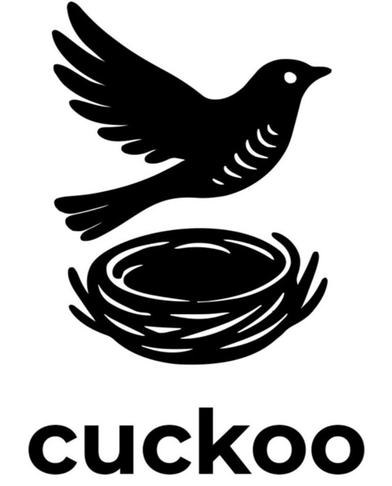
Date contacted candidate: | Start Date:
Date references received: | Induction checklist completed:
Taster Session Date:

Volunteer Application Form

Please complete all parts of this application form and give full answers. The more information you provide, the easier it will be for us to match you to a suitable role.

- PERSONAL DETAILS

Title | Surname | First Name(s)
Address |  | Home Tel
 |  | Mobile Tel
 |  | Email
Post Code |  | Date of Birth

Which day/s & times would you like to volunteer with us? | Monday AM PM  Tuesday AM PM  Wednesday AM PM | Thursday AM PM  Friday AM PM  Saturday AM PM

- BACKGROUND

What is your present occupation (i.e. employed, retired, carer etc)?

Tell us about yourself? Interests, hobbies or skills which you might feel would be useful within the shop environment?

Do you have any health problems or disabilities which might impact on your volunteering (e.g. heart, back, diabetes, epilepsy)? Anything that might make difficult for you to carry out parts of the work which is physically demanding? YES / NO
If 'Yes' please specify:

- INFORMATION IN SUPPORT OF YOUR APPLICATION
What attracts you to Cuckoo CIC rather than other Charities and what do you hope to gain from working with us?

How did you find out about volunteer opportunities at Cuckoo CIC?
Is there anything you think you may need help with?

4. REFERENCES
The nature of the work for Cuckoo CIC can bring volunteers into contact with vulnerable people. For this reason, we ask for the names of two people who have ideally known you for at least two years, who are not relatives and not residing at the same address. Your signature will be taken as agreement for us to contact the following.
Name | Name
Email | Email
Address | Address
Post Code | Post Code
Telephone No. | Telephone No.
Relationship | Relationship

REHABILITATION OF OFFENDERS ACT 1974

If you have any ‘unspent’ criminal convictions you are required to declare these.

Do you have any such convictions to disclose? YES / NO

If 'Yes' please give details below which will be treated in confidence.

Signature | Date

